Absolutely! Let's break down what a Class Diagram is and explain the one in your image.

**What is a Class Diagram?**

A Class Diagram is a type of Unified Modeling Language (UML) diagram that describes the structure of a system by showing its classes, their attributes, operations (or methods), and the relationships between the classes. It's a static diagram, meaning it represents the static structure of the system rather than its dynamic behavior.

**Key Elements of a Class Diagram:**

* **Classes:** Represented by rectangles divided into three sections:
  + **Class Name (Top Section):** The name of the class.
  + **Attributes (Middle Section):** The data members of the class.
  + **Operations/Methods (Bottom Section):** The functions or behaviors that the class can perform.
* **Attributes:** Describe the properties of a class. They typically include a name and a data type.
* **Operations/Methods:** Define the actions that a class can perform. They typically include a name, parameters, and a return type.
* **Relationships:** Show how classes are related to each other. Common relationships include:
  + **Association:** A general relationship indicating that objects of one class use objects of another class.
  + **Aggregation:** A "has-a" relationship, where one class is part of another.
  + **Composition:** A strong form of aggregation, where the parts cannot exist independently of the whole.
  + **Inheritance:** An "is-a" relationship, where one class inherits attributes and operations from another.
  + **Dependency:** A "uses-a" relationship, where one class uses another class.

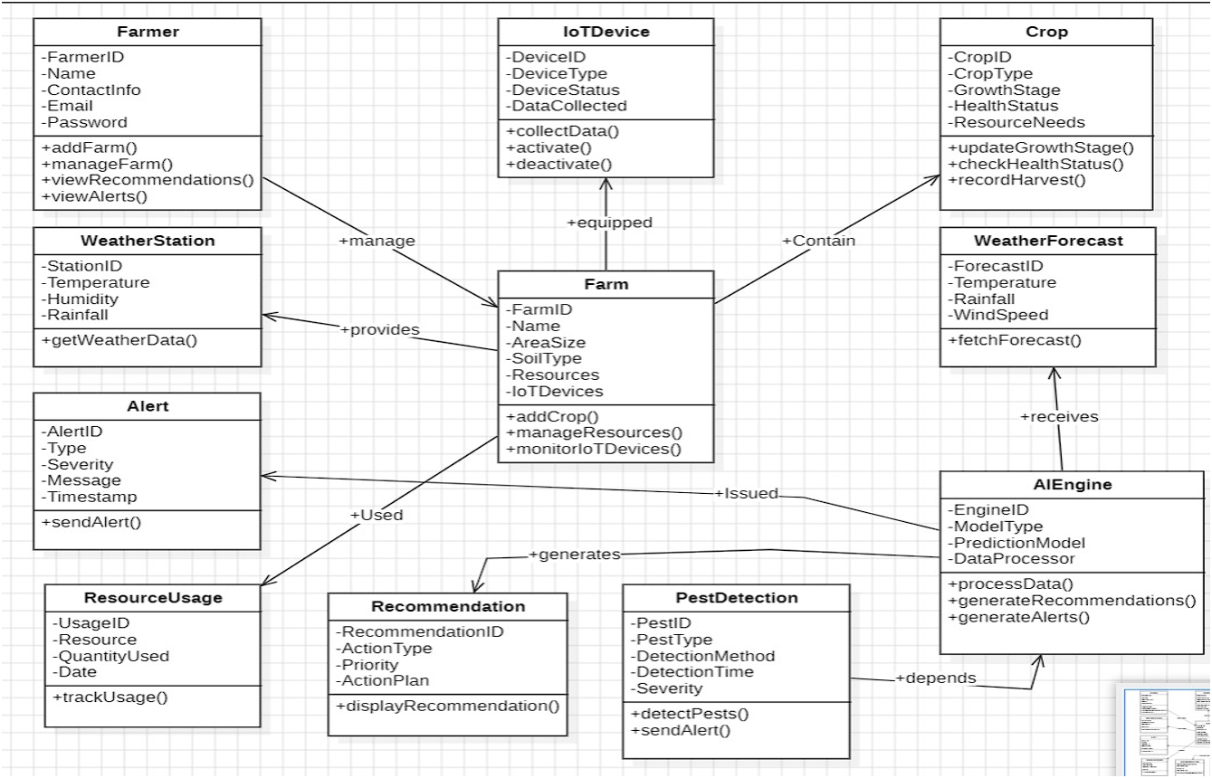

**Explanation of the Image (Class Diagram for Smart Agriculture System):**

The image presents a Class Diagram for a smart agriculture system. It outlines the various classes involved, their attributes, operations, and relationships.

**Classes and Their Attributes/Operations:**

1. **Farmer:**
   * **Attributes:** FarmerID, Name, ContactInfo, Email, Password.
   * **Operations:** addFarm(), manageFarm(), viewRecommendations(), viewAlerts().
2. **Farm:**
   * **Attributes:** FarmID, Name, AreaSize, SoilType, Resources, IoTDevices.
   * **Operations:** addCrop(), manageResources(), monitorIoTDevices().
3. **Crop:**
   * **Attributes:** CropID, CropType, GrowthStage, HealthStatus, ResourceNeeds.
   * **Operations:** updateGrowthStage(), checkHealthStatus(), recordHarvest().
4. **IoTDevice:**
   * **Attributes:** DeviceID, DeviceType, DeviceStatus, DataCollected.
   * **Operations:** collectData(), activate(), deactivate().
5. **WeatherStation:**
   * **Attributes:** StationID, Temperature, Humidity, Rainfall.
   * **Operations:** getWeatherData().
6. **WeatherForecast:**
   * **Attributes:** ForecastID, Temperature, Rainfall, WindSpeed.
   * **Operations:** fetchForecast().
7. **Alert:**
   * **Attributes:** AlertID, Type, Severity, Message, Timestamp.
   * **Operations:** sendAlert().
8. **ResourceUsage:**
   * **Attributes:** UsageID, Resource, QuantityUsed, Date.
   * **Operations:** trackUsage().
9. **Recommendation:**
   * **Attributes:** RecommendationID, ActionType, Priority, ActionPlan.
   * **Operations:** displayRecommendation().
10. **PestDetection:**
    * **Attributes:** PestID, PestType, DetectionMethod, DetectionTime, Severity.
    * **Operations:** detectPests(), sendAlert().
11. **AIEngine:**
    * **Attributes:** EngineID, ModelType, PredictionModel, DataProcessor.
    * **Operations:** processData(), generateRecommendations(), generateAlerts().

**Relationships:**

* **Farmer manages Farm:** An association.
* **Farm contains Crops:** An aggregation.
* **Farm is equipped with IoTDevices:** An association.
* **Farm provides WeatherStation data:** An association.
* **Farm receives WeatherForecast data:** An association.
* **ResourceUsage is used by Farm:** An association.
* **Alert is issued by AIEngine:** A dependency.
* **Recommendation is generated by AIEngine:** A dependency.
* **PestDetection depends on AIEngine:** A dependency.

**Interpretation:**

This Class Diagram represents the static structure of a smart agriculture system. It shows the classes involved, their attributes, operations, and relationships. It provides a blueprint for the system's architecture and helps in understanding how the different components interact.

**Key Takeaways:**

* It provides a clear overview of the system's structure.
* It shows the relationships between different components.
* It serves as a foundation for system design and development.
* It presents an overview of the data and actions that the system will handle